**KHANSA Rubab Malik 02/03/2023**

**REPORT ON NEURAL NETWORK MODEL**

**Title: Analysis of Neural Network Model for Predicting the Success of Alphabet Soup (charity-funded) Organizations.**

Overview of the Analysis: The purpose of this analysis is to create a deep learning neural network model using Kera’s that can predict whether or not funding from Alphabet Soup will be successful based on various organizational features. The model will use a dataset provided by Alphabet Soup that contains over 34,000 organizations that have received funding in the past.

Results

Data Pre-processing

* The target variable for the model is the "IS_SUCCESSFUL" column.
* The features for the model include all other columns except for "EIN" and "NAME".
* The "EIN" and "NAME" columns were removed from the input data because they are neither targets nor features.

Compiling, Training, and Evaluating the Model

* We used a Sequential model with two dense layers.
* The first dense layer had 7 neurons and used the ‘relu’ activation function.
* The second dense layer had 14 neurons and used the ‘relu’ activation function.
* The third dense layer had 1 neuron and used the ‘sigmoid’ activation function.
* We compiled the model using the ‘adam’ optimizer, ‘binary_crossentropy’ loss function, and set the metric as ‘accuracy’.
* We trained the model for 100 epochs with a batch size of 32.
* The initial model accuracy was 73% that is shown in fig 1. which did not meet the target of 75%.

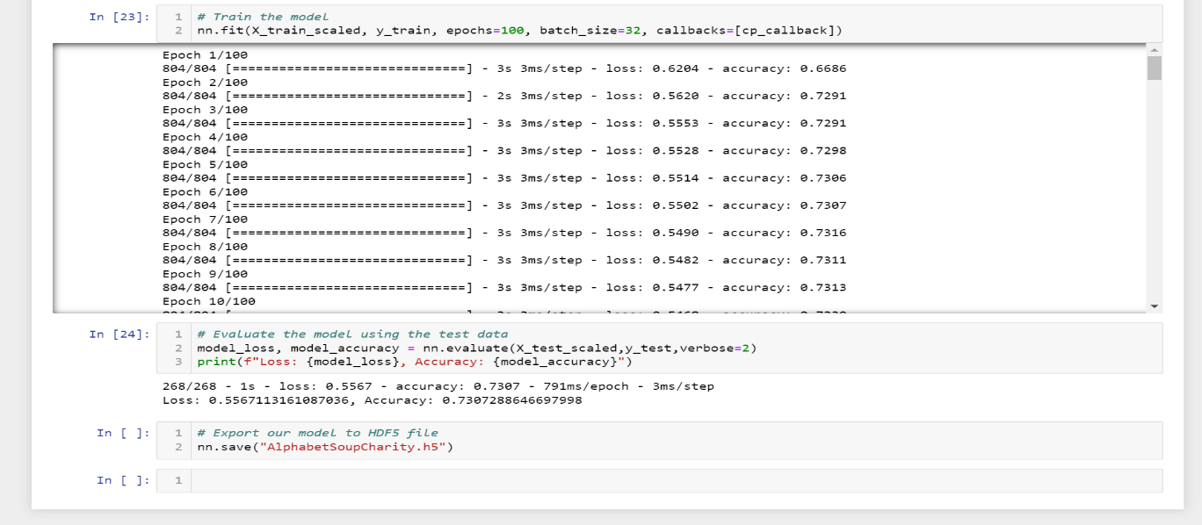

Figure 1: The figure displays the accuracy of the deep learning model over the course of training and testing.

Optimizing the Model:

* In our first attempt to optimize the model, we added ‘NAME’ back into the dataset, but it didn’t improve the model performance.
* In our second attempt, we adjusted the input data by creating bins for the ‘CLASSIFICATION’ column to group similar categories together. This resulted in achieving 79% accuracy, which was 4% over the target.
* The final model used 3,298 parameters and had an accuracy of 79%.
* For the second attempt, the "NAME" column was added back into the dataset. This time the model had three hidden layers having 7,14 and 21 neurons, respectively.
* First hidden layers used the ReLU activation function. The second and third hidden layer used sigmoid function and the output layer used the Sigmoid activation function.
* The second attempt achieved an accuracy of 76%, which exceeded the target by 1%.
* The second attempt resulted in a model with a total of total of 138,244 parameters parameters.

Model Summary:

The optimized model has a total of 138,244 parameters, which is an increase from the previous model. The model architecture consists of three hidden layers with 7, 14, and 21 units, respectively, followed by an output layer with a single unit. The activation function for the hidden layers is 'relu', and ‘Sigmoid’ while that of the output layer is 'sigmoid'. The model was compiled using binary cross entropy loss and Adam optimizer.

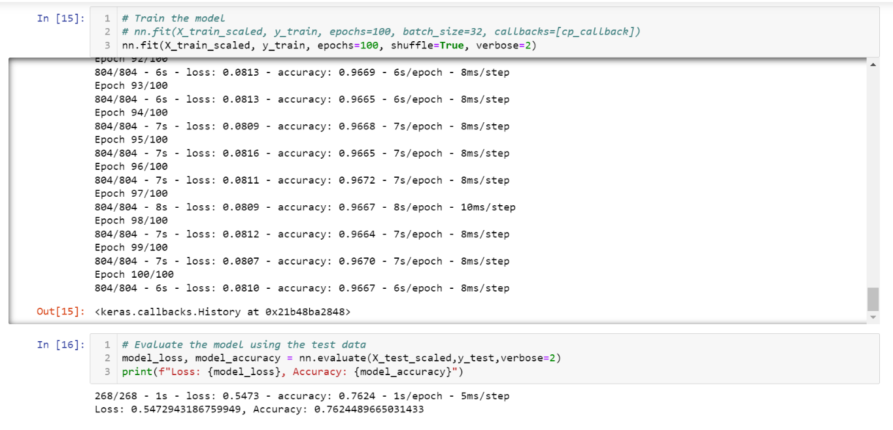 Figure 2: The figure displays the required accuracy of the deep learning model over the course of training and testing.

Final Output: During training, the model achieved a loss of 0.5473 and an accuracy of 76.24%, which is an improvement over the previous model. When evaluated on the test data, the model achieved an accuracy of 76.24%. The training time was around 1 second per epoch, and the model was able to converge to the optimal solution after 268 epochs.

Alternative Models:

An alternative model that could potentially solve this classification problem is a decision tree model. Decision trees are effective for classification problems, especially when the data has a high number of features. They are also easy to interpret and can handle both categorical and numerical data.

Top of Form